**CSRF,** or Cross-Site Request Forgery, is a type of security vulnerability where an attacker tricks a victim's browser into making an unwanted request to a web application on which the victim is authenticated. The attacker aims to perform actions on behalf of the victim without their consent. Here's an example to help illustrate how a CSRF attack works:

Scenario: Online Banking CSRF Attack

Vulnerable Web Application:

Consider an online banking website that allows users to transfer money between accounts by submitting a form.

User Authentication:

When a user logs into their online banking account, the server issues them a session token, which is stored as a cookie in their browser. This token is used to authenticate subsequent requests from the user.

Exploitable Form:

The online banking website includes a form for transferring money between accounts. The form might look like this:

html

Copy code

<form action="https://bank.example.com/transfer" method="post">

<input type="hidden" name="amount" value="1000">

<input type="hidden" name="toAccount" value="attackerAccount">

<input type="submit" value="Transfer Money">

</form>

Crafting the CSRF Attack:

The attacker creates a malicious website and embeds the above form in it. They entice the victim to visit their website, perhaps through a phishing email or a malicious link.

Victim's Browser Submits Unauthorized Request:

When the victim visits the malicious website, their browser automatically submits the hidden form without their knowledge. The form includes parameters like the amount and the destination account (controlled by the attacker).

Authentication Bypass:

Since the victim is already authenticated to the online banking website, the browser includes the authentication cookie with the forged request. The online banking server, unable to distinguish between a legitimate and forged request, processes the transfer as if the legitimate user initiated it.

Unauthorized Money Transfer:

The unauthorized request successfully transfers money from the victim's account to the attacker's account, all without the victim's explicit consent.

To prevent CSRF attacks, web applications can implement security measures such as anti-CSRF tokens. These tokens are unique, per-session values included in forms, making it challenging for attackers to forge requests because they won't have the correct token.

Anti-CSRF (Cross-Site Request Forgery) tokens are security measures implemented by web applications to protect against CSRF attacks. CSRF attacks involve an attacker tricking a user's browser into making an unintended and potentially malicious request to a target website where the user is authenticated. Anti-CSRF tokens add an additional layer of security to ensure that requests made to the server are legitimate and come from the intended user.

Here's how Anti-CSRF tokens typically work:

Token Generation:

When a user logs into a web application, the server generates a unique, random token associated with the user's session.

Token Inclusion in Forms:

The server includes this token as a hidden field in every form that could potentially trigger state-changing actions (e.g., submitting a form to change account settings, perform financial transactions, etc.).

html

Copy code

<form action="/update-settings" method="post">

<input type="hidden" name="csrf_token" value="randomToken123">

<!-- Other form fields go here -->

<input type="submit" value="Submit">

</form>

Token Verification on Submission:

When the user submits the form, the server checks if the CSRF token included in the request matches the one associated with the user's session. If the tokens match, the request is considered legitimate.

Protection Against CSRF Attacks:

Since the attacker cannot predict or obtain the user's Anti-CSRF token due to the same-origin policy (which restricts access to resources from different origins), the presence of the correct token in the request is a strong indication that the request is legitimate.

By requiring a valid Anti-CSRF token for state-changing actions, web applications can significantly reduce the risk of CSRF attacks. It ensures that only requests initiated from within the application and by the authenticated user are accepted, making it much more difficult for attackers to forge requests and perform unauthorized actions on behalf of the user.

==================================================================================

Cross-Site Scripting (XSS) is a type of security vulnerability where attackers inject malicious scripts into web applications that are then executed by the victims' browsers. XSS attacks enable attackers to steal sensitive information, manipulate web page content, or perform actions on behalf of users without their consent. There are three main types of XSS attacks, each with its own characteristics:

Stored XSS (Persistent XSS):

Description:

In a Stored XSS attack, the malicious script is permanently stored on the target server, typically in a database or another data store. When a user retrieves the affected web page, the script is served along with the legitimate content.

Attack Scenario:

An attacker may inject malicious code (e.g., JavaScript) into a user-generated content field, such as a forum post, comment, or profile bio. When other users access the affected page containing the stored payload, their browsers execute the malicious script.

Example:

Attacker injects <script>alert("Stored XSS");</script> into a comment on a blog. When other users view the comment, the script executes, displaying an alert box with the message "Stored XSS."

Reflected XSS (Non-Persistent XSS):

Description:

Reflected XSS occurs when the injected script is included in the web page's URL or in a form submission, and it is immediately reflected back to the user. The payload is not stored on the server; instead, it is part of the user's request and is embedded in the response.

Attack Scenario:

An attacker may craft a malicious link or URL containing the payload and trick a user into clicking it. The payload is then reflected in the response, and the user's browser executes the script.

Example:

Attacker crafts a URL like http://example.com/search?q=<script>alert("Reflected XSS");</script>. When a user clicks the link, the script executes, showing an alert box.

DOM-based XSS:

Description:

DOM-based XSS occurs when the web application's client-side scripts manipulate the Document Object Model (DOM) based on user input in an unsafe way. The malicious script is executed in the user's browser, and the DOM is manipulated dynamically.

Attack Scenario:

An attacker may exploit JavaScript functions that dynamically update the DOM based on user input. By injecting malicious input, the attacker manipulates the DOM, leading to the execution of the injected script.

Example:

A web page uses JavaScript to update the page content based on a user's language preference. If the language preference is not properly sanitized, an attacker could inject <script>alert("DOM-based XSS");</script> as the language preference, leading to script execution.

Preventing XSS attacks involves input validation, output encoding, and implementing security mechanisms like Content Security Policy (CSP) to mitigate the impact of such vulnerabilities. Regular security audits and awareness training are also essential for robust defense against XSS attacks.

===========================================================

Denial of Service: -

A Denial-of-Service (DoS) attack is a malicious attempt to disrupt the normal functioning of a targeted system, network, or service by overwhelming it with a flood of traffic or resource requests. The primary goal of a DoS attack is to render the targeted system or service unavailable to its intended users, causing a denial of service.

Here are key characteristics and types of DoS attacks:

Types of DoS Attacks:

Traffic-Based Attacks:

Flooding Attacks: Overwhelm the target with a high volume of traffic, consuming available bandwidth and resources. Common types include ICMP (Ping) Floods, SYN/ACK Floods, and UDP Reflection/Amplification Attacks.

Protocol Exploitation:

Application-Layer Attacks: Target vulnerabilities in applications or services, aiming to exhaust server resources. Examples include HTTP/HTTPS Floods, Slowloris, and HTTP POST Floods.

Resource Exhaustion:

TCP/IP Stack Attacks: Exploit vulnerabilities in the TCP/IP protocol stack, causing the target system to exhaust resources. For example, Teardrop attacks and Ping of Death.

Distributed Denial-of-Service (DDoS) Attacks:

DDoS attacks involve multiple compromised computers (known as a botnet) coordinated to launch a simultaneous attack on a target. DDoS attacks are often more challenging to mitigate due to the distributed nature of the attack traffic.

Symptoms of a DoS Attack:

Unusually Slow Performance: Services become slow or unresponsive due to the overwhelming volume of traffic.

Service Outages: Websites or online services become unavailable to legitimate users.

Increased Latency: Delays in processing legitimate requests due to resource exhaustion.

Inability to Access Resources: Users experience difficulties accessing specific resources or services.

Mitigation Strategies:

Network Filtering: Implementing firewalls and intrusion prevention systems to filter out malicious traffic.

Traffic Monitoring: Employing monitoring tools to detect and analyze abnormal traffic patterns.

Rate Limiting: Restricting the rate of incoming requests to prevent resource exhaustion.

Load Balancing: Distributing traffic across multiple servers to avoid a single point of failure.

Content Delivery Networks (CDNs): Using CDNs to distribute content and absorb DDoS traffic.

Buffer overflow: too much information is being passed into a container that does not have enough space, and that information ends up replacing data in adjacent containers.

Buffer overflows can be exploited by attackers with a goal of modifying a computer’s memory in order to undermine or take control of program execution.

Smurf attack:

A Smurf attack is a type of network-layer Distributed Denial of Service (DDoS) attack that takes advantage of the Internet Control Message Protocol (ICMP) and the concept of broadcast amplification.

Here's how a Smurf attack typically works:

ICMP Echo Request (Ping):

The attacker sends a large number of ICMP Echo Request (ping) packets to a broadcast address on a network. These ping packets contain the spoofed source IP address of the victim.

Broadcast Amplification:

Due to the nature of broadcast communication in some networks, every host on that network receives and processes the ICMP Echo Request. This results in multiple responses being generated for each ICMP packet sent by the attacker.

Amplified Traffic:

The victim's IP address is spoofed in such a way that the responses from the broadcasted ICMP Echo Requests are directed to the victim's IP address.

Traffic Overwhelm:

The victim's system becomes inundated with a large volume of ICMP Echo Reply (ping reply) traffic, causing it to consume available bandwidth, processing power, and other resources.

The key characteristics of a Smurf attack are:

Amplification: The attack takes advantage of broadcast amplification, causing multiple responses for each packet sent by the attacker.

Spoofing: The attacker spoofs the source IP address in the ICMP packets, making it appear as if the victim is requesting the ping replies.

Traffic Overwhelm: The targeted system or network becomes overwhelmed with ICMP traffic, leading to a denial-of-service condition.

To mitigate Smurf attacks, network administrators can take the following measures:

Disable IP Directed Broadcasts:

Configure routers and switches to block directed broadcasts, preventing them from being forwarded.

Filtering Spoofed Packets:

Implement filters on network devices to block incoming packets with a source IP address that doesn't belong to the local network. This helps prevent IP address spoofing.

Rate Limit ICMP Responses:

Implement rate limiting for ICMP responses to prevent excessive responses for a single request.

Ingress Filtering:

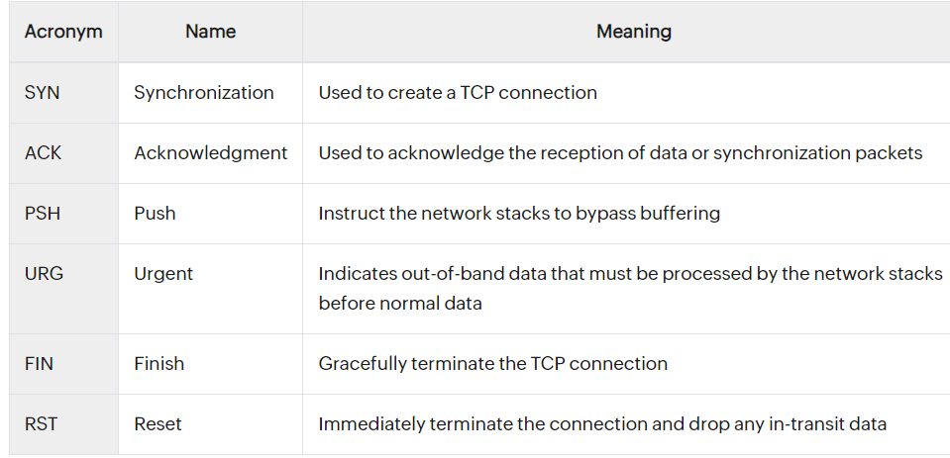Employ ingress filtering at the network perimeter to block packets with spoofed source addresses.

The PSH and URG flags

When sending data, any side in the TCP connection may additionally use the PSH and URG flags (which respectively mean “push” and “urgent”). The PSH flags instruct the operating system to send (for the sending side) and receive (for the receiving side) the data immediately. In other words, this flag instructs the operating system’s network stack to send/receive the entire content of its buffers immediately.

Without this flag, the operating system might decide to wait before sending or passing the received data to the application because it wants to wait for more data to be sent or received to maximize the utilization of the host and network resources. However, some applications would want the data to be sent and received as soon as practically possible, for example with an SSH session or at the end of an HTTP request or response.

The URG flag is used to signal “urgent” data that should be prioritized over non-urgent data. This is used to send so-called “out-of-band data,” which is treated in a special way by the operating system and usually signals some kind of exception in the application protocol. Note that in practice, this feature of TCP is seldom used.

False Positive:

An intrusion detection system triggers an alert for malicious activity, but upon further investigation, it is revealed that the detected activity was a normal and harmless operation.

False Negative:

Definition: A false negative occurs when a security tool or system fails to detect a real security threat, classifying it as safe or benign.

Example: An antivirus software fails to detect a new strain of malware, allowing it to execute on a system without being flagged.